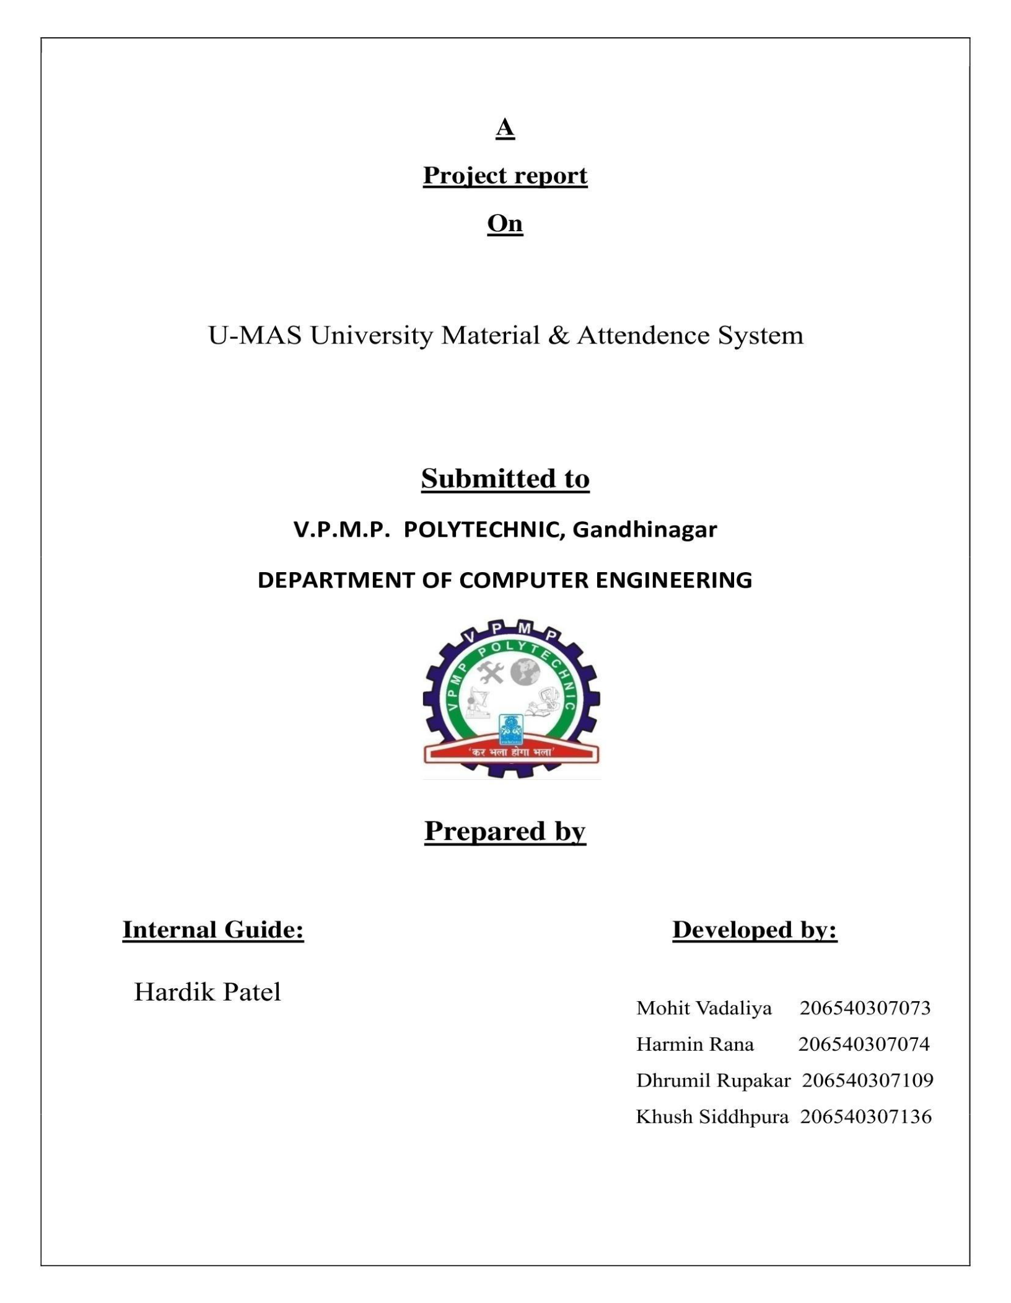

Tushar Oza

University Material & Attendance System 1 | Page

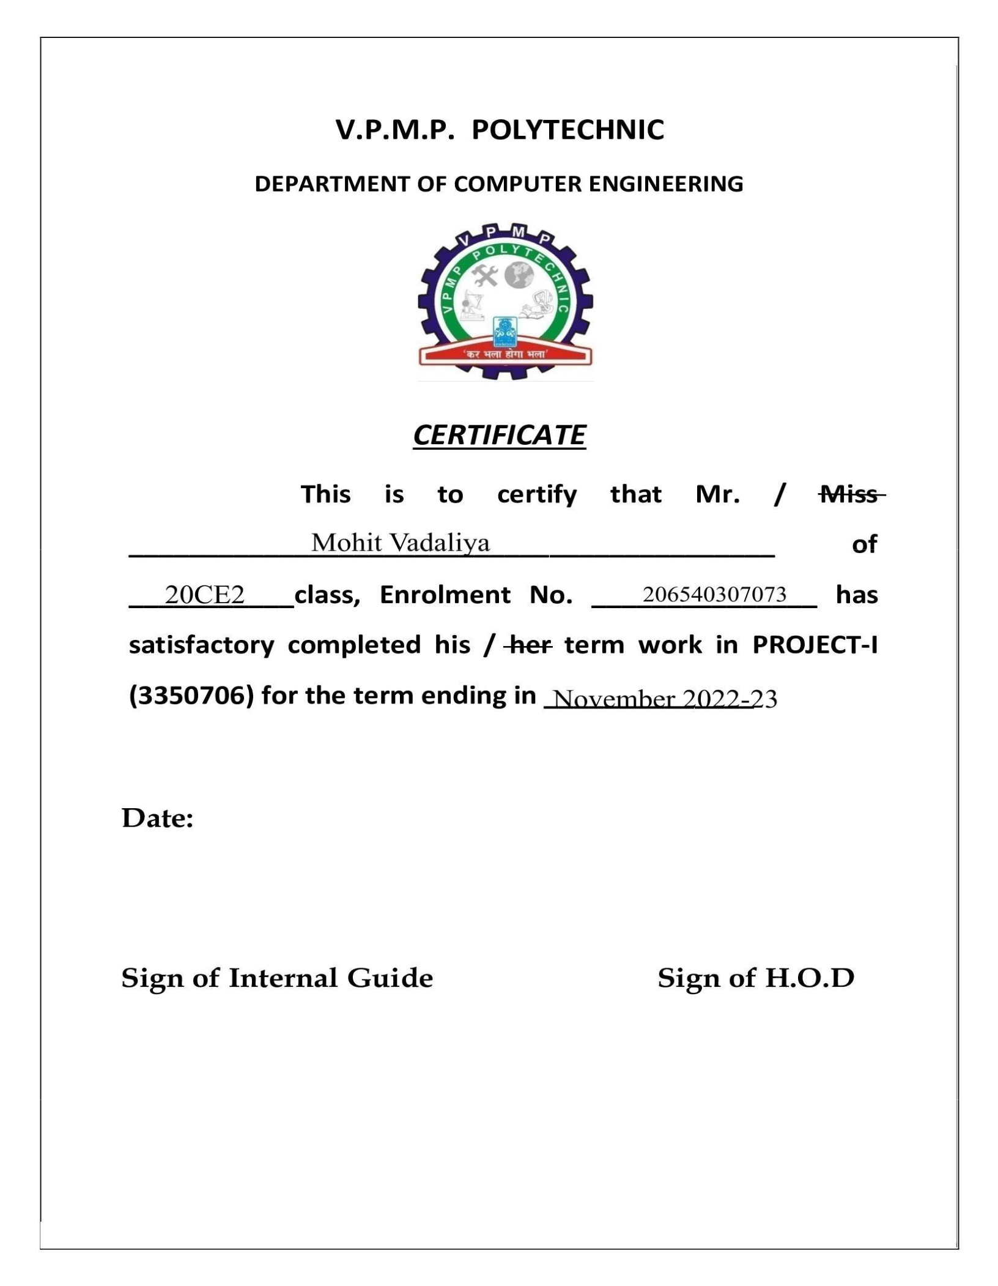

University Material & Attendance System 2 | Page

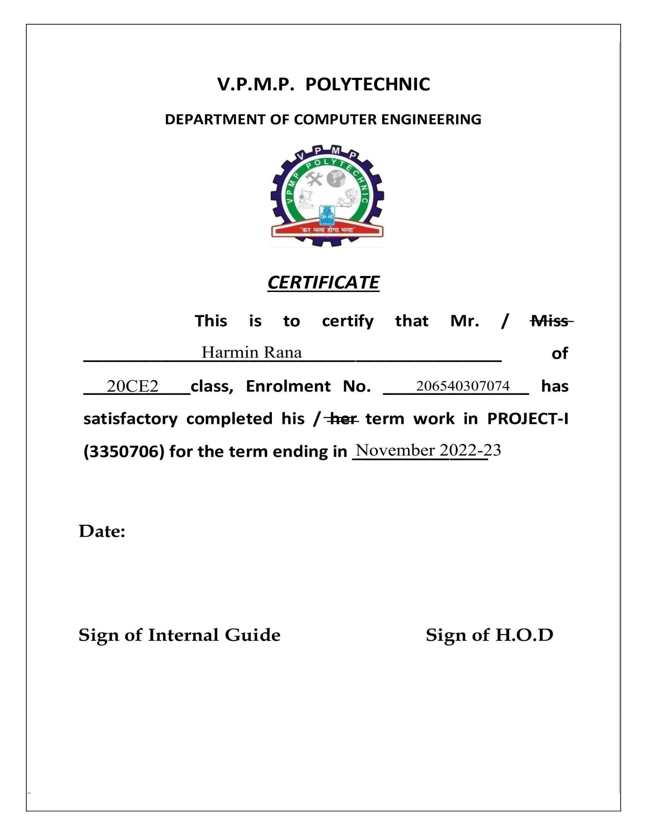

University Material & Attendance System 3 | Page

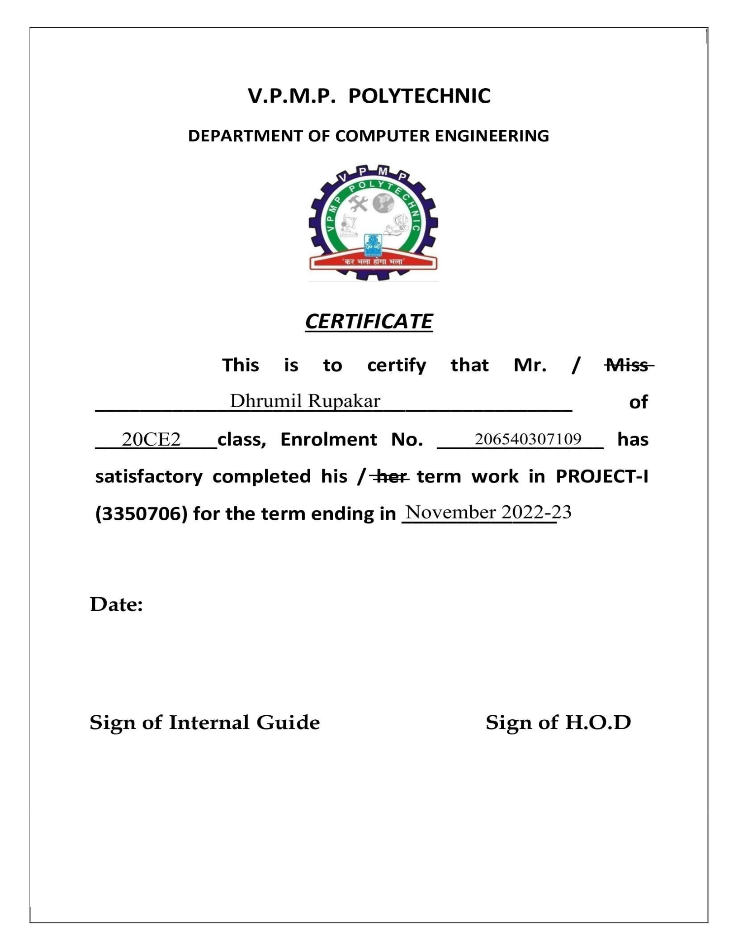

University Material & Attendance System 4 | Page

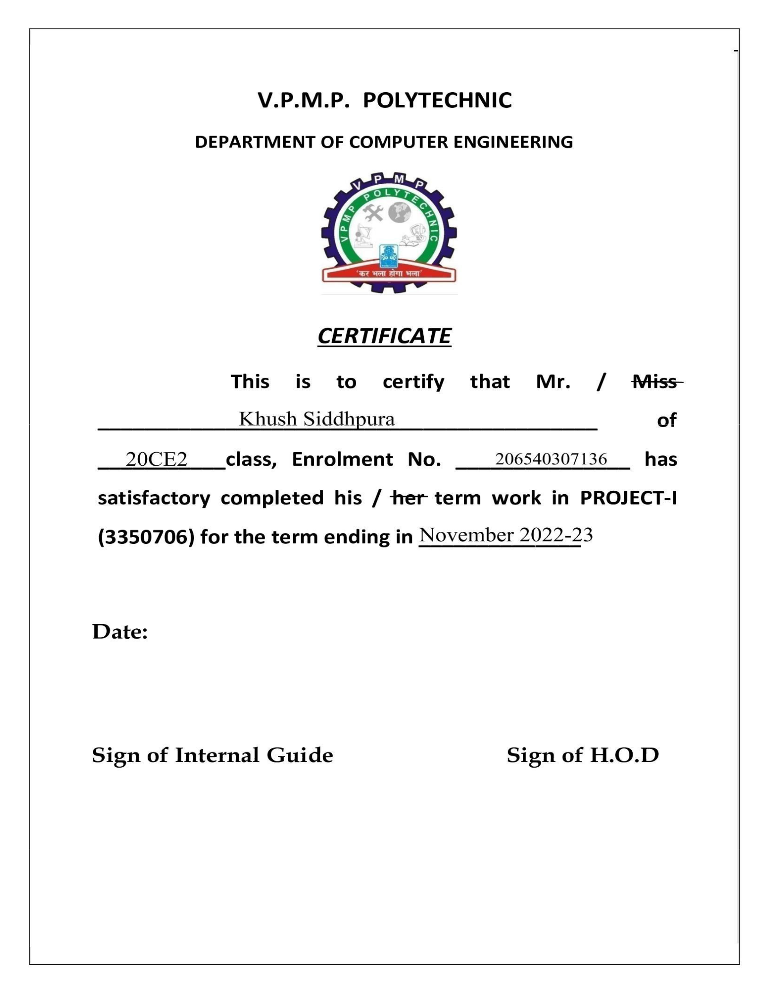

University Material & Attendance System 5 | Page

**Abstract:**

Our main focus is to design a unique Student Management system that will improve Data management in Institutes, experience for both Students and the Administration authorities. The whole system will run on the web browser. The system is written in Python. Users will have the ability to log in from any place with internet connection. After that they will be able to access various resources and important notices, tasks provided by the faculties. Student Management System is a website which is helpful for students as well as the school/college authorities. In the current system all the activities are done manually. It is very time consuming and costly. Our Student Management System deals with the various activities related to the students.

image9.png

University Material & Attendance System 6 | Page

**INDEX**

|  |  |
| --- | --- |
| **NAME** | **PG.NO** |
|  |  |
| Introduction | 08 |
| System Analysis | 09-10 |
|  |  |
| Feasibility Analysis | 11 |
| Hardware Configuration | 12 |
|  |  |
| Software Configuration | 12 |
| Context Diagram & DFD | 13-14 |
|  |  |
| Screenshots | 15-23 |
| System Design | 24 |
|  |  |
| Output | 25 |
| Database | 26 |
|  |  |
| System Implementation | 27 |
| Software Testing | 28 |
|  |  |
| **Conclusion** | 29 |
| **Bibliography** | 30 |
|  |  |

image9.png

University Material & Attendance System 7 | Page

**Introduction**

* University material and Attendance is a website which is helpful for students as well as the school/college authorities. In the current system all activities are done manually. It is very time consuming and costly. Our system management deals with the various activities related to students.
* There are mainly 3 modules in this website
  + Faculty module
  + Student Module
  + Attendance & Material management

In the website we can register as a user and the user has two types, student and administrator. Administrator has the power to add, delete new users or manipulate the controls of a student user account. A student can register as a user and can access various resources such as study materials, notices, time-table, upload his/her work, edit and delete his profile. The administrator can inform all students about any particular event or study related affair by uploading a notice and also provide them a time-table for their regular study schedule or any examination. All the users can see the attendance.

image9.png

University Material & Attendance System 8 | Page

**System Analysis**

**EXISTING SYSTEM:**

System Analysis is a detailed study of the various operations performed by a system and their relationships within and outside of the system. Here the key question is- what all problems exist in the present system? What must be done to solve the problem? Analysis begins when a user or manager begins a study of the program using an existing system.

During analysis, data collected on the various files, decision points and transactions handled by the present system. The commonly used tools in the system are Data Flow Diagram, interviews, etc. Training, experience and common sense are required for collection of relevant information needed to develop the system. A good analysis model should provide not only the mechanisms of problem understanding but also the framework of the solution. Thus, it should be studied thoroughly by collecting data about the system. Then the proposed system should be analysed thoroughly in accordance with the needs.

System analysis can be categorised into four parts.

* System planning and initial investigation
* Information Gathering
* Applying analysis tools for structured analysis
* Feasibility study
* Cost/ Benefit analysis.

In the current system we need to keep a number of records related to the student and want to enter the details of the student and the attendance manually. In this system only, the teacher or the school authority views the attendance of the student and they want to enter the details of the student. This is time consuming and has many costs.

image9.png

University Material & Attendance System 9 | Page

**PROPOSED SYSTEM:**

In our proposed system we have the provision for adding the details of the students by themselves. So, the overhead of the school authorities and the teachers has become less. Another advantage of the system is that it is very easy to edit the details of the student and delete a student when it is found unnecessary. The marks of the student are added in the database and so students can also view the marks whenever they want. Our proposed system has several advantages:

* User friendly interface
* Fast access to database
* Less error
* More Storage Capacity

Look and Feel Environment Quick Transaction All the manual difficulties in managing the student details in a school or college have been rectified by implementing computerisation.

image9.png

University Material & Attendance System 10 | Page

**FEASIBILITY ANALYSIS**

Whatever we think need not be feasible. It is wise to think about the feasibility of any problem we undertake. Feasibility is the study of impact, which happens in the organisation by the development of a system. The impact can be either positive or negative. When the positives nominate the negatives, then the system is considered feasible. Here the feasibility study can be performed in two ways such as technical feasibility and Economical Feasibility.

TECHNICAL FEASIBILITY:

We can strongly say that it is technically feasible, since there will not be much difficulty in getting required resources for the development and maintaining the system as well. All the resources needed for the development of the website as well as the maintenance of the same are available in the organisation where we are utilising the resources which are available already.

ECONOMIC FEASIBILITY:

Development of this website is highly economically feasible. The organisation needed not spend much money for the development of the system already available. The only thing to be done is making an environment for development with effective supervision. If we are doing so, we can attain the maximum usability of the corresponding resources. Even after the development, the organisation will not be in condition to invest more in the organisation. Therefore, the system is economically feasible

image9.png

University Material & Attendance System 11 | Page

**CONFIGURATION**

* + **HARDWARE CONFIGURATION:**
* **RAM:** 1 GB
  + - **Software CONFIGURATION:**
* **OS:** windows / MacOS
* **OS version:** Windows 7+ / MacOS Monterey

image9.png

University Material & Attendance System 12 | Page

**Context Diagram DATA FLOW DIAGRAM**

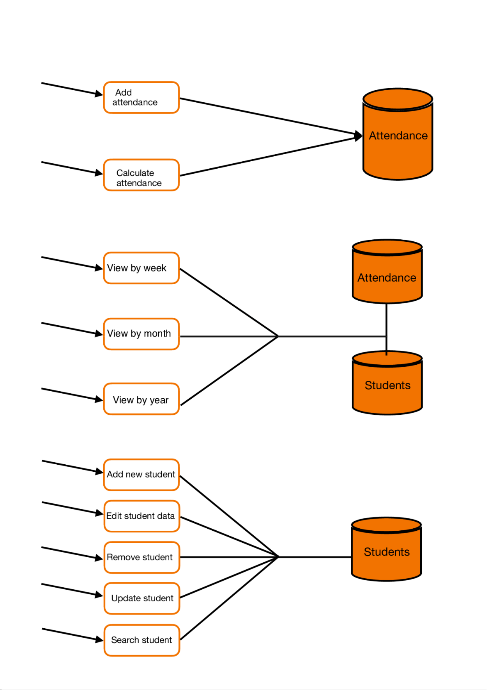

University Material & Attendance System 13 | Page

University Material & Attendance System 14 | Page

**Website Interface**

**Login Page**

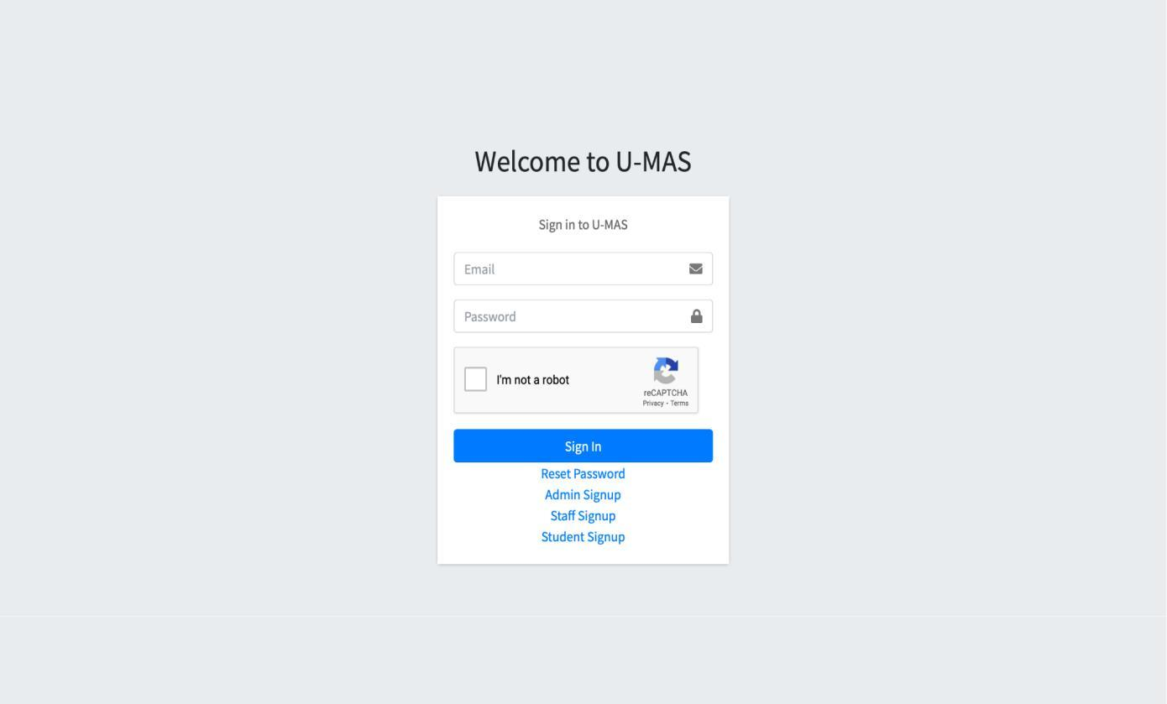

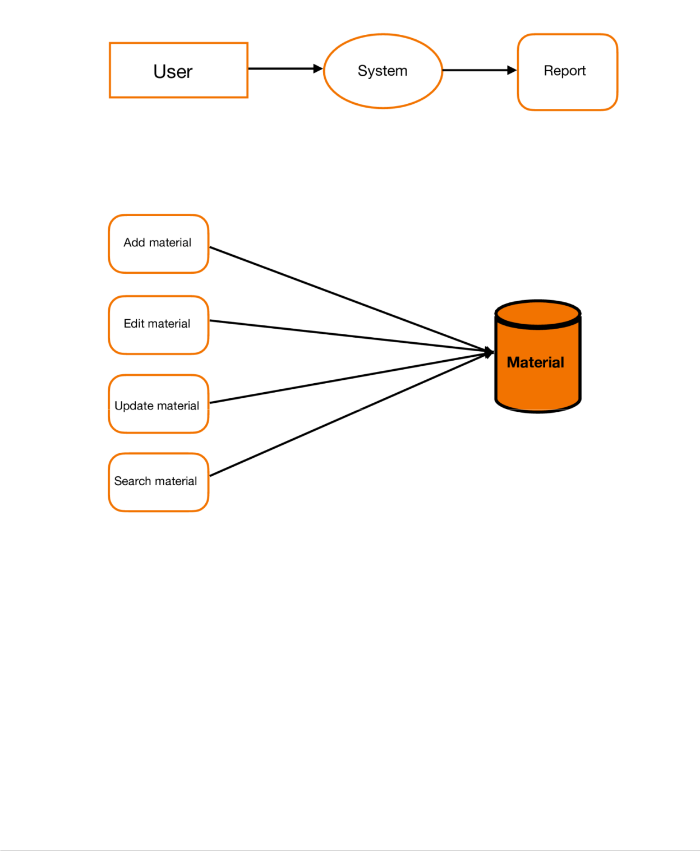image9.png

University Material & Attendance System 15 | Page

**HOD HOME PAGE**

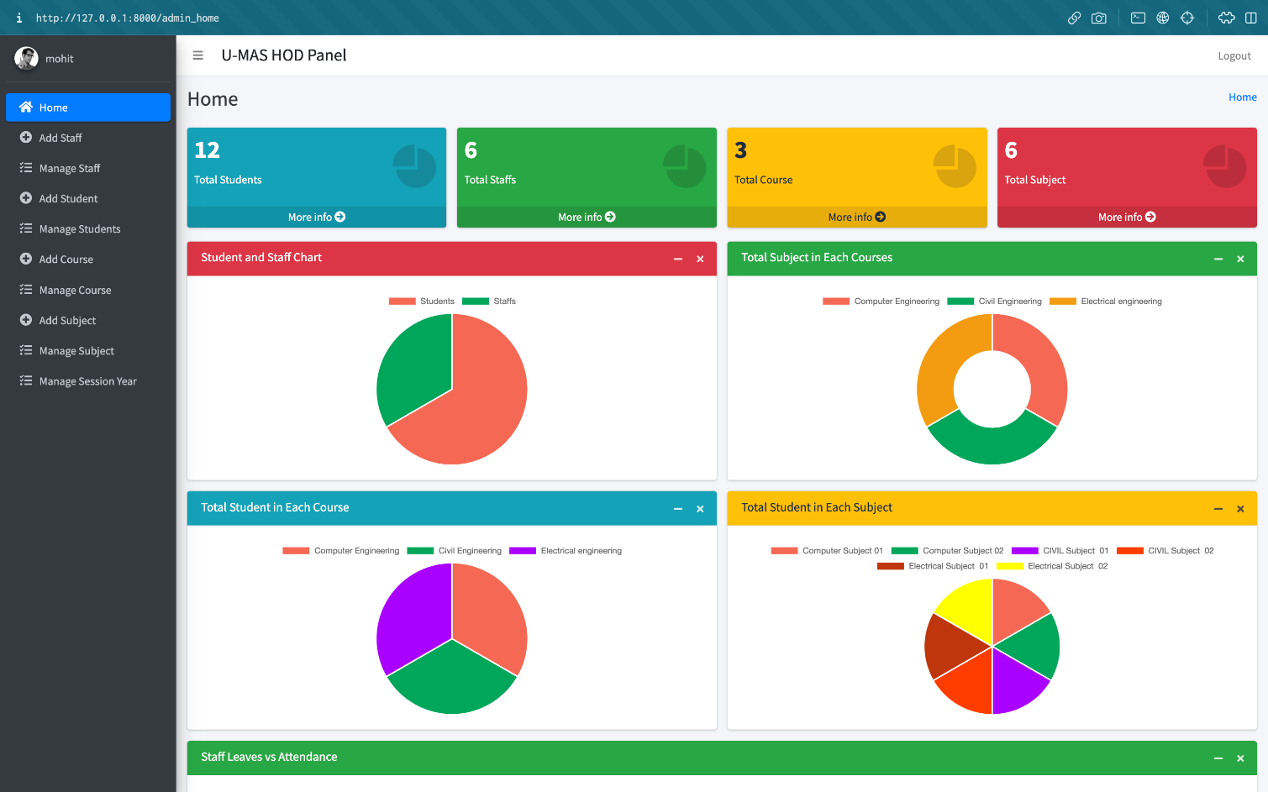

image9.png

University Material & Attendance System 16 | Page

**STAFF HOME PAGE**

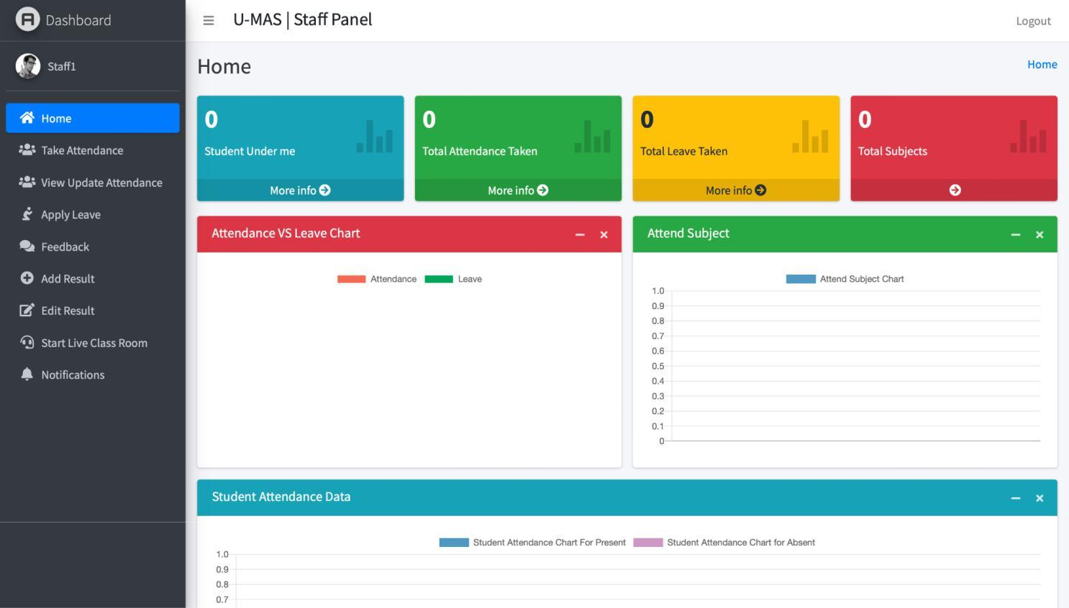

image9.png

University Material & Attendance System 17 | Page

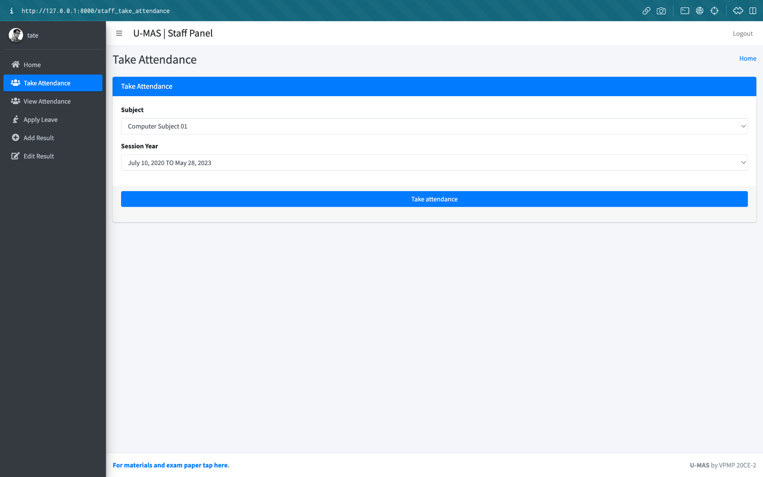

Universitimage9.pngy Material & Attendance System 18 | Page

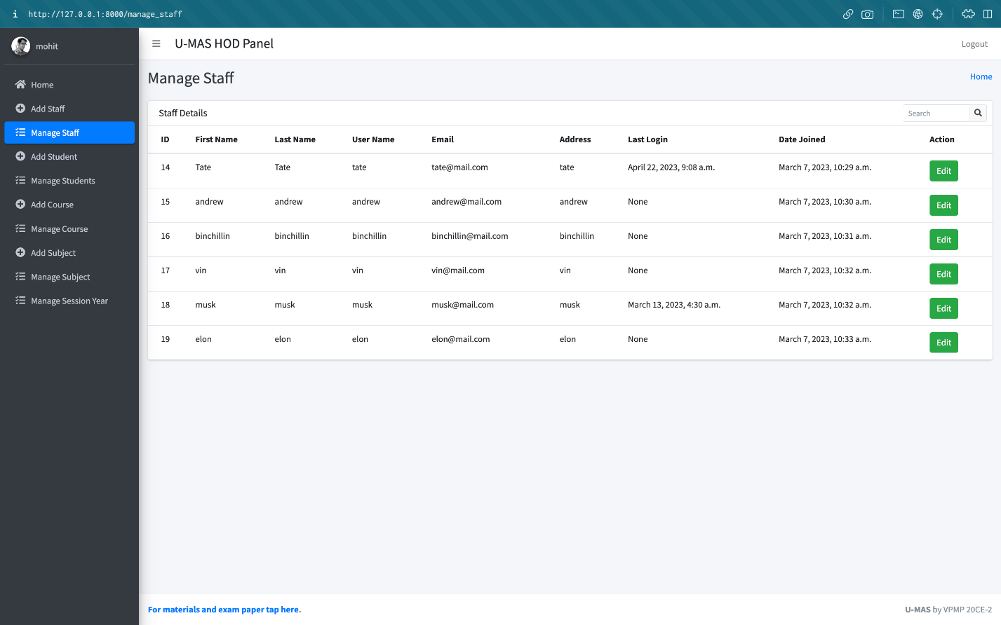

**MANAGE STUDENTS & STAFF**

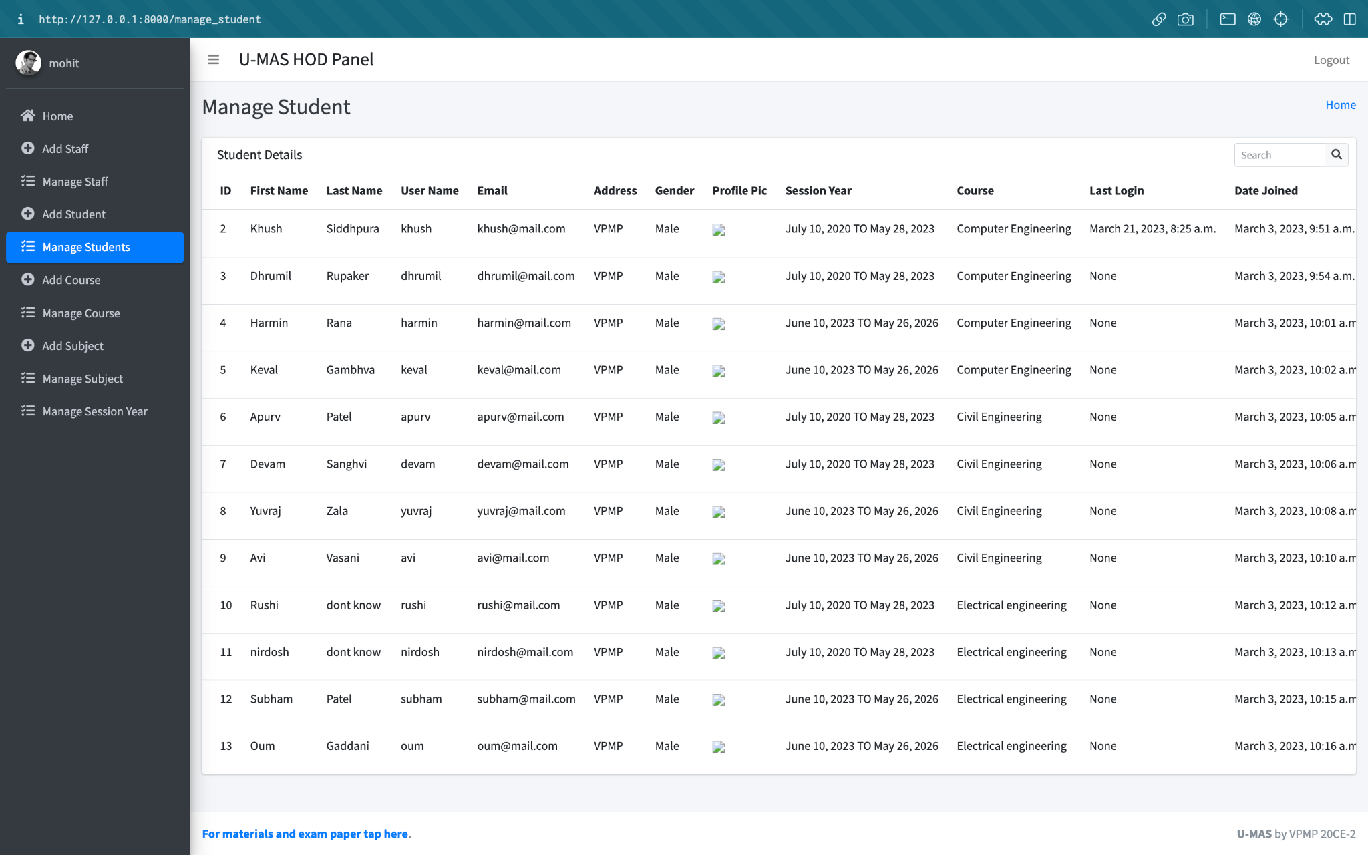

Universiimage9.pngty Material & Attendance System 19 | Page

**STUDENT HOME PAGE**

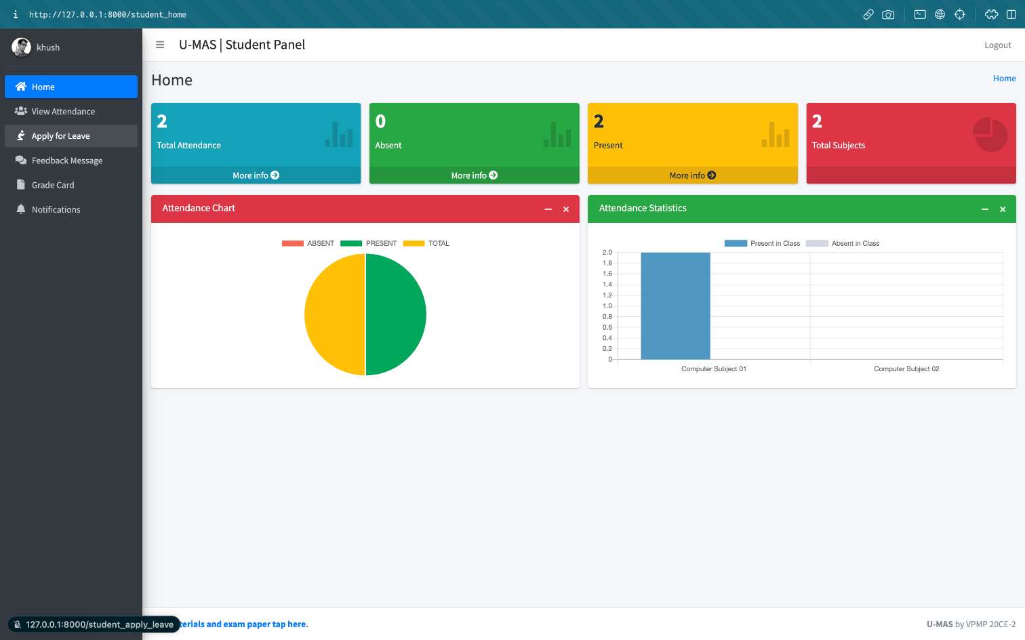

University Material &image9.png Attendance System 20 | Page

**VIEWS .py**

image9.png

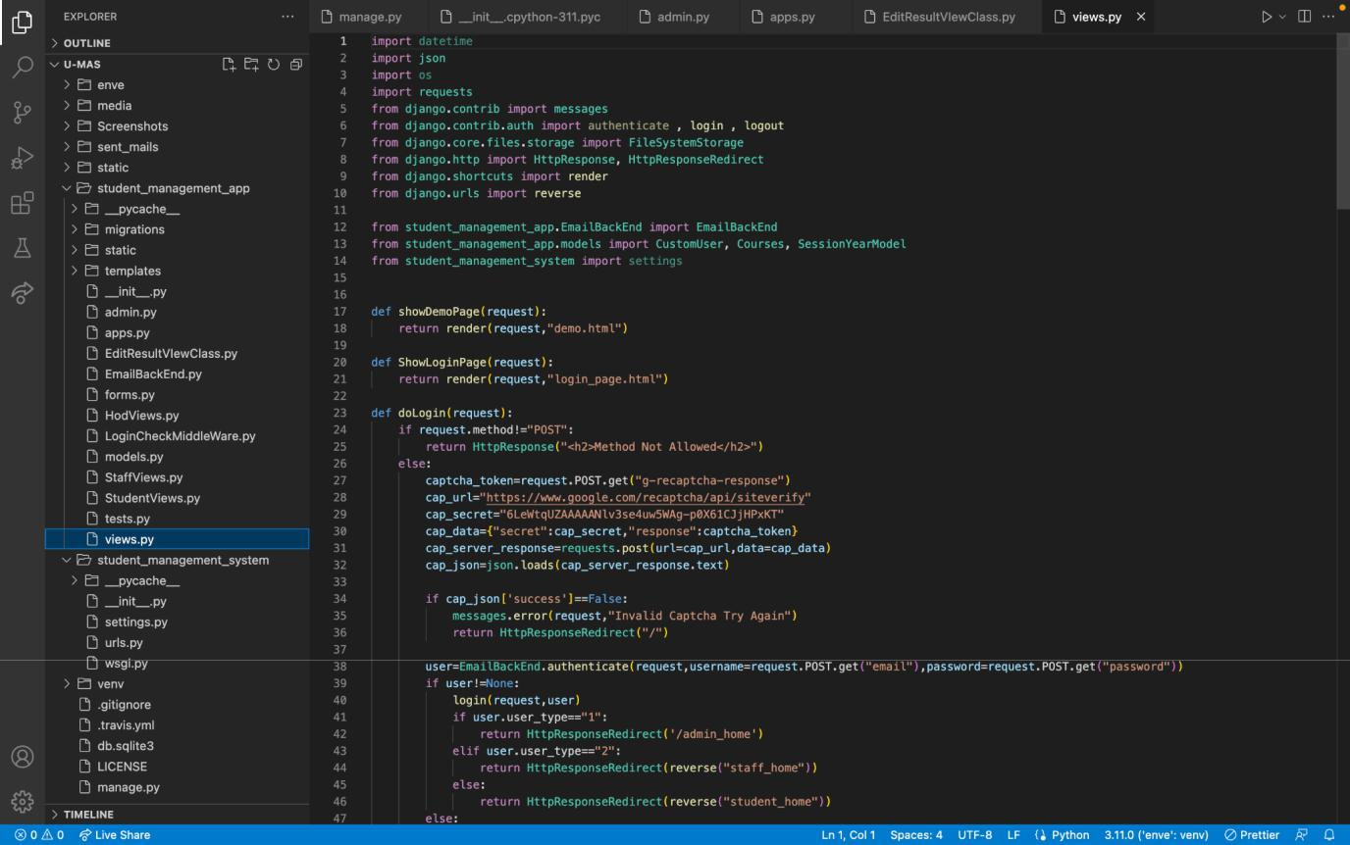

image9.png

University Material & Attendance System 21 | Page

image9.png

**URLS.py**

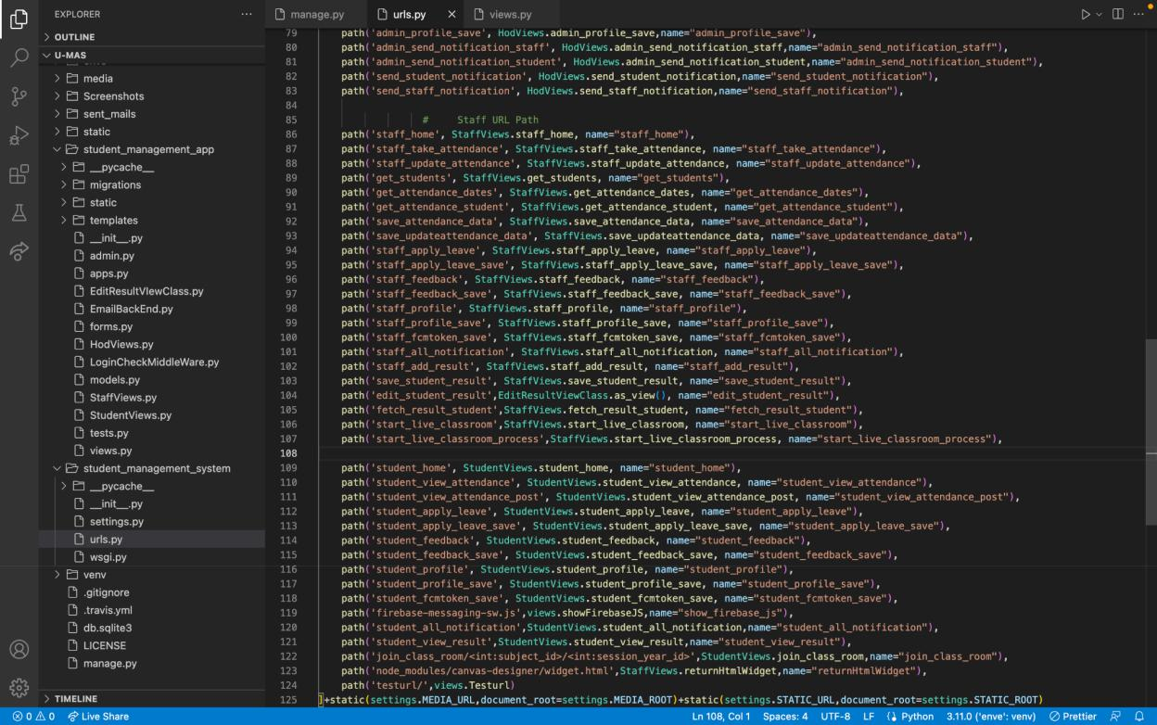

University Material & Attendance System 22 | Page

image9.png

**MODELS.py**

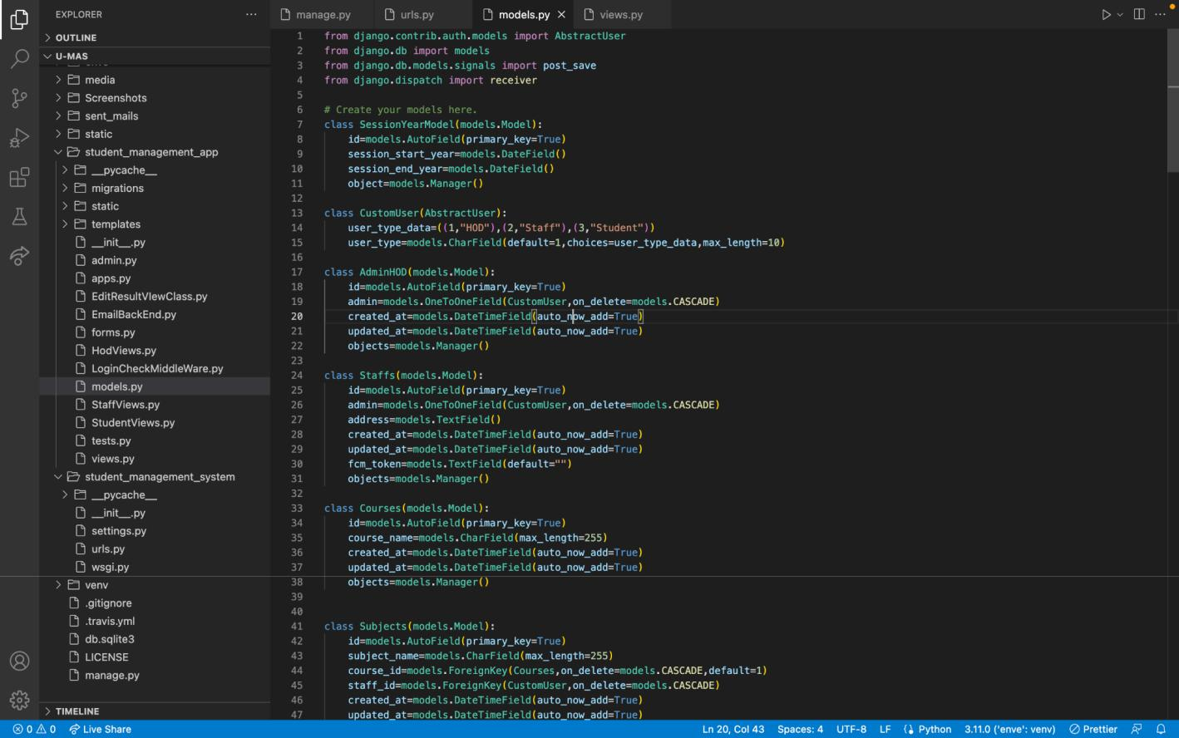

University Material & Attendance System 23 | Page

**SYSTEM DESIGN**

**INPUT DESIGN**

Input design is the process of converting user-oriented input to a computer based format. Input design is a part of overall system design, which requires very careful attention. Often the collection of input data is the most expensive part of the system. The main objectives of the input design are …

1. Produce cost effective method of input
2. Achieve highest possible level of accuracy
3. Ensure that the input is acceptable to and understood by the staff.

**INPUT DATA:**

The goal of designing input data is to make entry easy, logical and free from errors as possible. The entering data entry operators need to know the allocated space for each field; field sequence and which must match with that in the source document. The format in which the data fields are entered should be given in the input form. Here data entry is online; it makes use of a processor that accepts commands and data from the operator through a keyboard. The input required is analysed by the processor. It is then accepted or rejected. Input stages include the following processes.

* Data Recording
* Data Transcription
* Data Conversion
* Data Verification
* Data Control
* Data Transmission
* Data Correction

One of the aims of the system analyst must be to select data capture methods and devices, which reduce the number of stages so as to reduce both the changes of errors and the cost. Input types can be characterised as.

* External
* Internal
* Operational
* Computerised
* Interactive

Input files can exist in document form before being input to the computer. Input design is rather complex since it involves procedures for capturing data as well as inputting it to the computer.image9.png

University Material & Attendance System 24 | Page

**OUTPUT**

Outputs from computer systems are required primarily to communicate the results of processing to users. They are also used to provide a permanent copy of these results for later consultation. Computer output is the most important and direct source of information to the users. Designing computer output should proceed in an organised well throughout the manner. The right output must be available for the people who find the system easy to use. The outputs have been defined during the logical design stage. If not, they should have been defined at the beginning of the output designing terms of types of output connect, format, response etc.

Various types of outputs are

* External outputs
* Internal outputs
* Operational outputs
* Interactive outputs
* Turn around outputs

All screens are informative and interactive in such a way that the user can full fill his requirements through asking queries

image9.png

University Material & Attendance System 25 | Page

**DATABASE**

The general theme behind a database is to handle information as an integrated whole. A database is a collection of interrelated data stored with minimum redundancy to serve many users quickly and effectively. After designing input and output, the analyst must concentrate on database design or how data should be organized around user requirements. The general objective is to make information access easy, quick, inexpensive and flexible for other users. During database design the following objectives are concerned: -

* Controlled Redundancy
* sData independence
* Accurate and integrating
* More information at low cost
* Recovery from failure
* Privacy and security
* Performance
* Ease of learning and use

image9.png

University Material & Attendance System 26 | Page

**SYSTEM IMPLEMENTATION**

Implementation is the stage in the project where the theoretical design is turned into a working system. The implementation phase constructs, installs and operates the new system. The most crucial stage in achieving a new successful system is that it will work efficiently and effectively.

There are several activities involved while implementing a new project. They are

* End user training
* End user Education
* Training on the website software
* System Design
* Parallel Run and To New System
* Post implementation Review

End user Training:

The successful implementation of the new system will purely upon the involvement of the officers working in that department. The officers will be imparted the necessary training on the new technology

End User Education:

The education of the end user starts after the implementation and testing is over. When the system is found to be more difficult to understand and complex, more effort is put into educating the end user to make them aware of the system, giving them lectures about the new system and providing them necessary documents and materials about how the system can do this.

Training of website software:

After providing the necessary basic training on the computer awareness, the users will have to be trained upon the new system such as the screen flows and screen design type of help on the screen, type of errors while entering the data, the corresponding validation check at each entry and the way to correct the data entered. It should then cover information needed by the specific user or group to use the system.

Post Implementation View:

The department is planning a method to know the states of the past implementation process. A regular meeting will be arranged by the concerned officers about the implementation problem and success.image9.png

University Material & Attendance System 27 | Page

**SOFTWARE TESTING**

Is the menu bar displayed in the appropriate contested some system related features included either in menus or tools? Do pull –Down menu operation and Tool-bars work properly? Are all menu functions and pull-down sub functions properly listed; Is it possible to invoke each menu function using a logical assumption that if all parts of the system are correct, the goal will be successfully achieved. In adequate testing or non-testing will lead to errors that may appear a few months later.

This create two problem

1. Time deimage9.pnglay between the cause and appearance of the problem.
2. The effect of the system errors on files and records within the system

The purpose of the system testing is to consider all the likely variations to which it will be suggested and push the systems to limits.

The testing process focuses on the logical intervals of the software ensuring that all statements have been tested and on the functional interval is conducting tests to uncover errors.

University Material & Attendance System 28 | Page

**CONCLUSION**

Our project is only a humble venture to satisfy the needs in an Institution. Several user-friendly coding has also been adopted. This package shall prove to be a powerful package in satisfying all the requirements of the organisation.

The objective of software planning is to provide a framework that enables the manager to make rimage9.pngeasonable estimates made within a limited time frame at the beginning of the software project and should be updated regularly as the project progresses. Last but not least it is not the work that played the ways to success but ALMIGHTY.

University Material & Attendance System 29 | Page

**BIBLIOGRAPHY**

* <https://github.com/python>
* <https://youtu.be/6gNpSuE01qE>
* <https://xd.adobe.com/ideas/process/ui-design/>
* <https://youtu.be/hKB-YGF14SY>
* <https://youtu.be/JxzZxdht-XY>
* <https://adminlte.io/>
* <https://youtube.com/playlist?list=PLu0W_9lII9ah7DDtYtflgwMwpT3xmjXY9>\
* https://sass-lang.com/

image9.png

University Material & Attendance System 30 | Page